Figure S5 the forest plots of sensitive tests

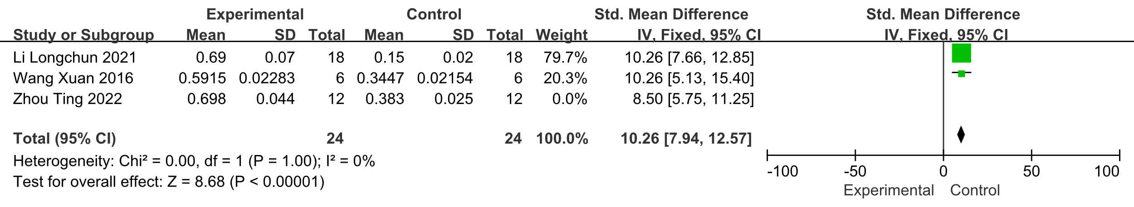

1 Forest plot of Akt for sensitivity test

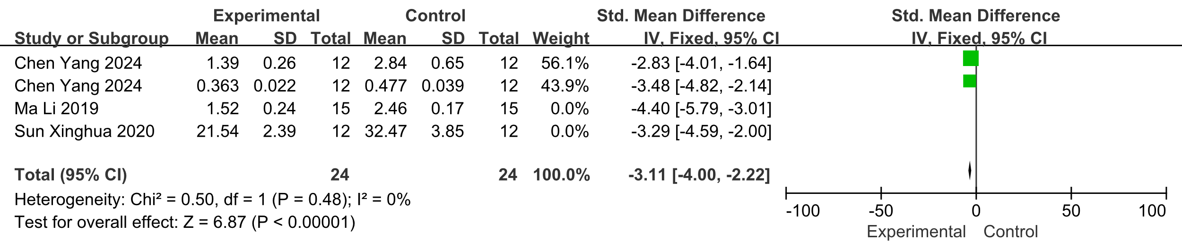

2 Forest plot of Bax for sensitivity test

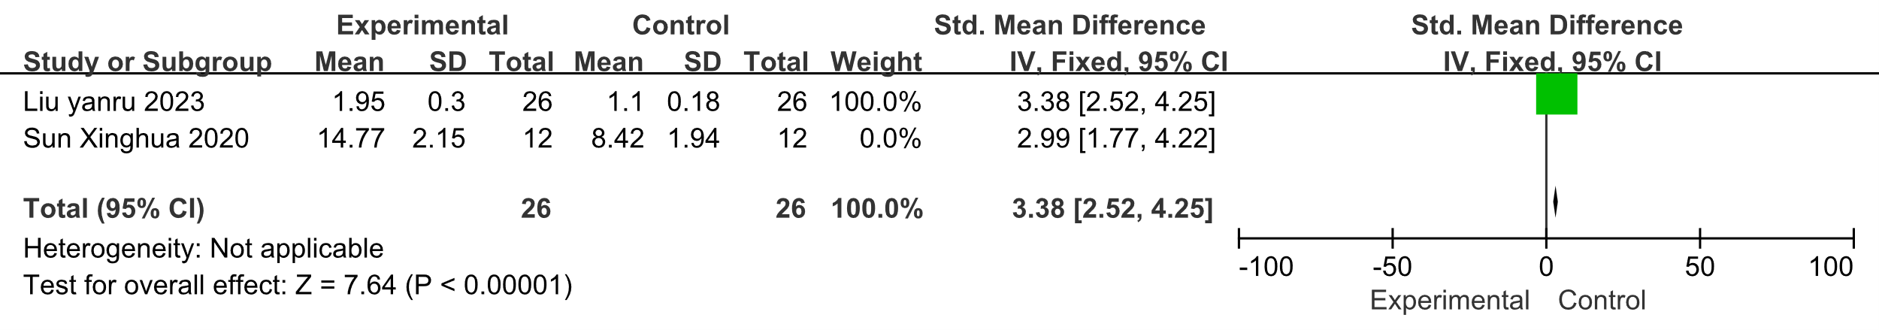

3 Forest plot of Bcl-2 for sensitivity test

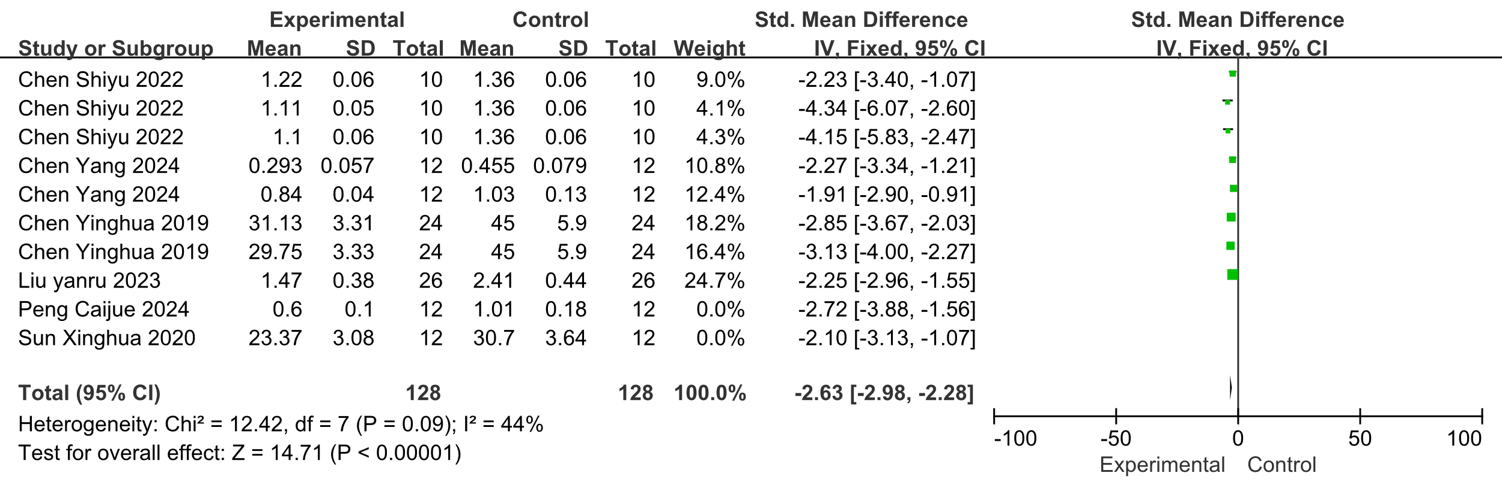

4 Forest plot of Caspase-3 for sensitivity test

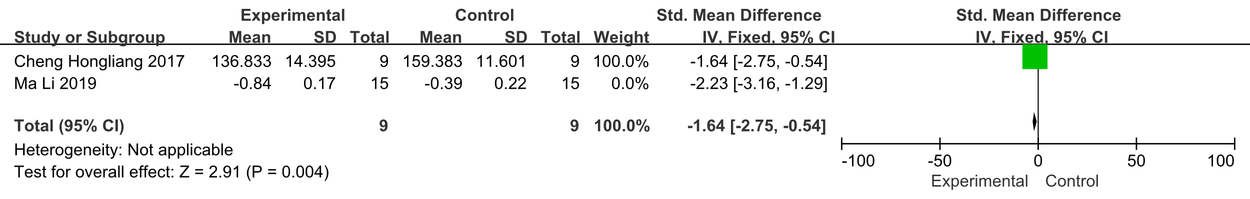

5 Forest plot of ERK for sensitivity test

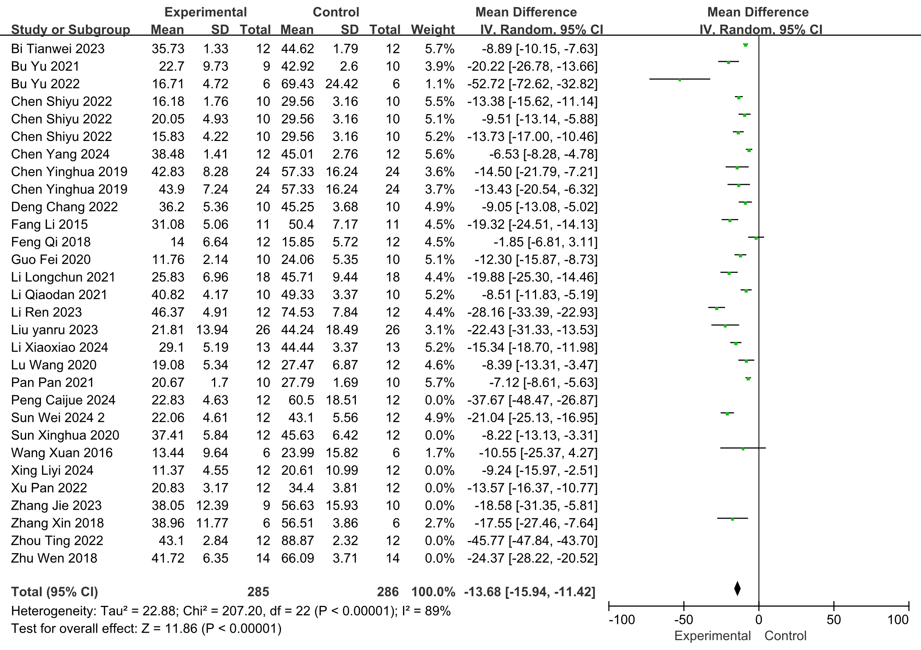

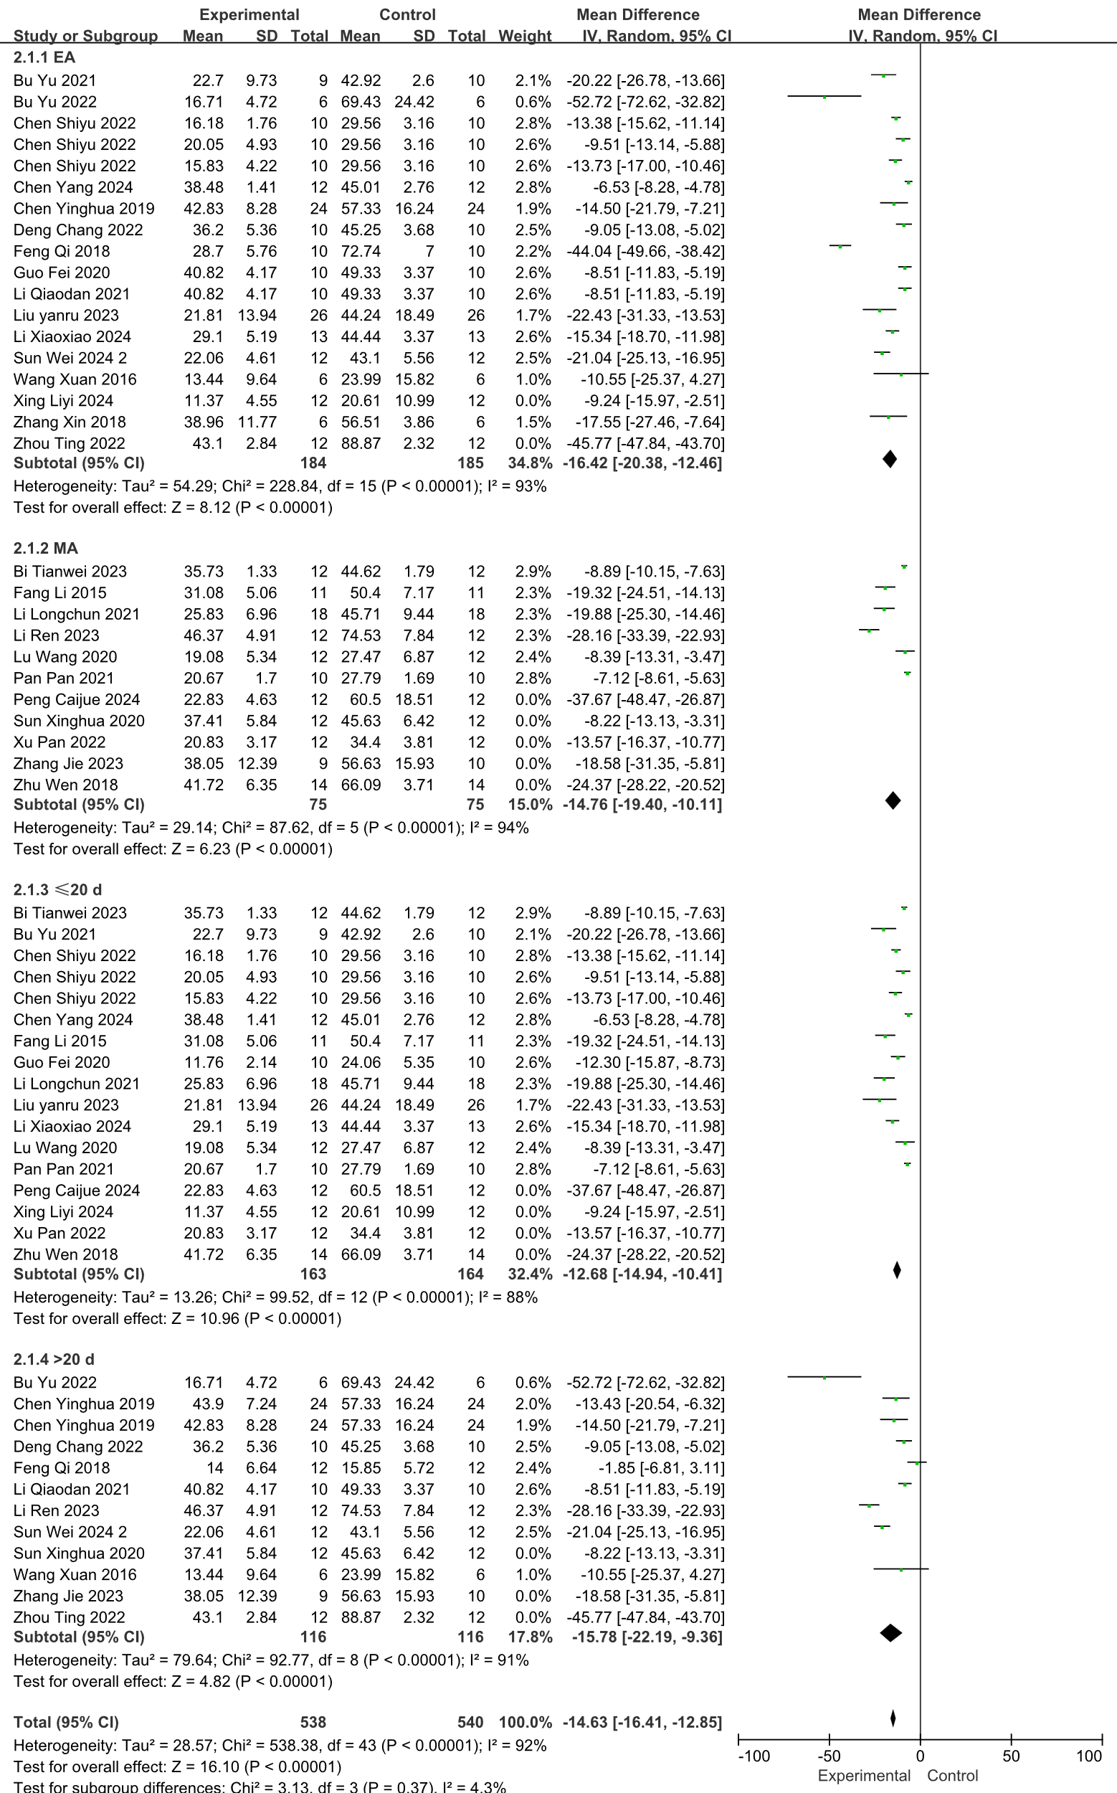

6 Forest plot of escape latency for sensitivity test

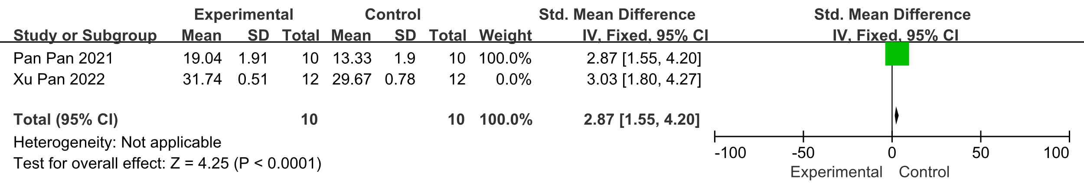

7 Forest plot of IL-4 for sensitivity test

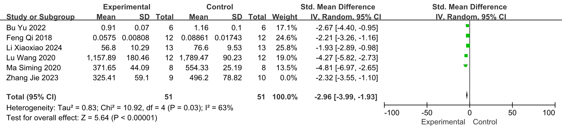

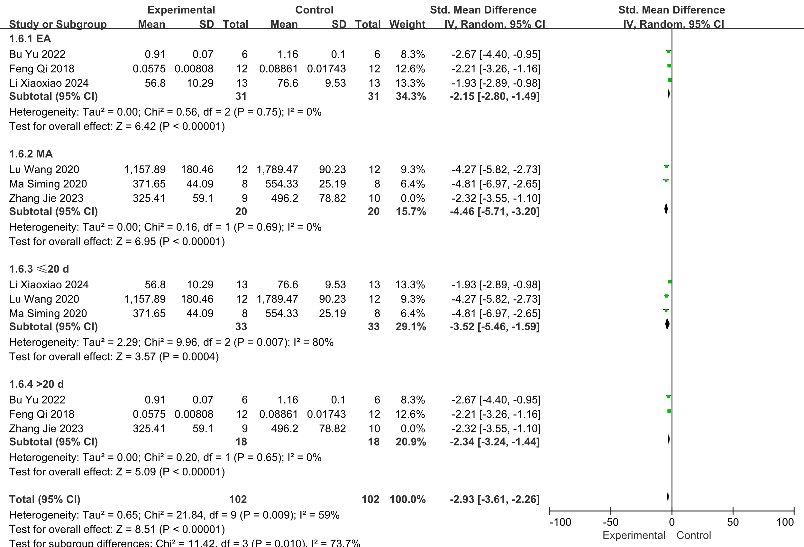

8 Forest plot of IL-6 for sensitivity test

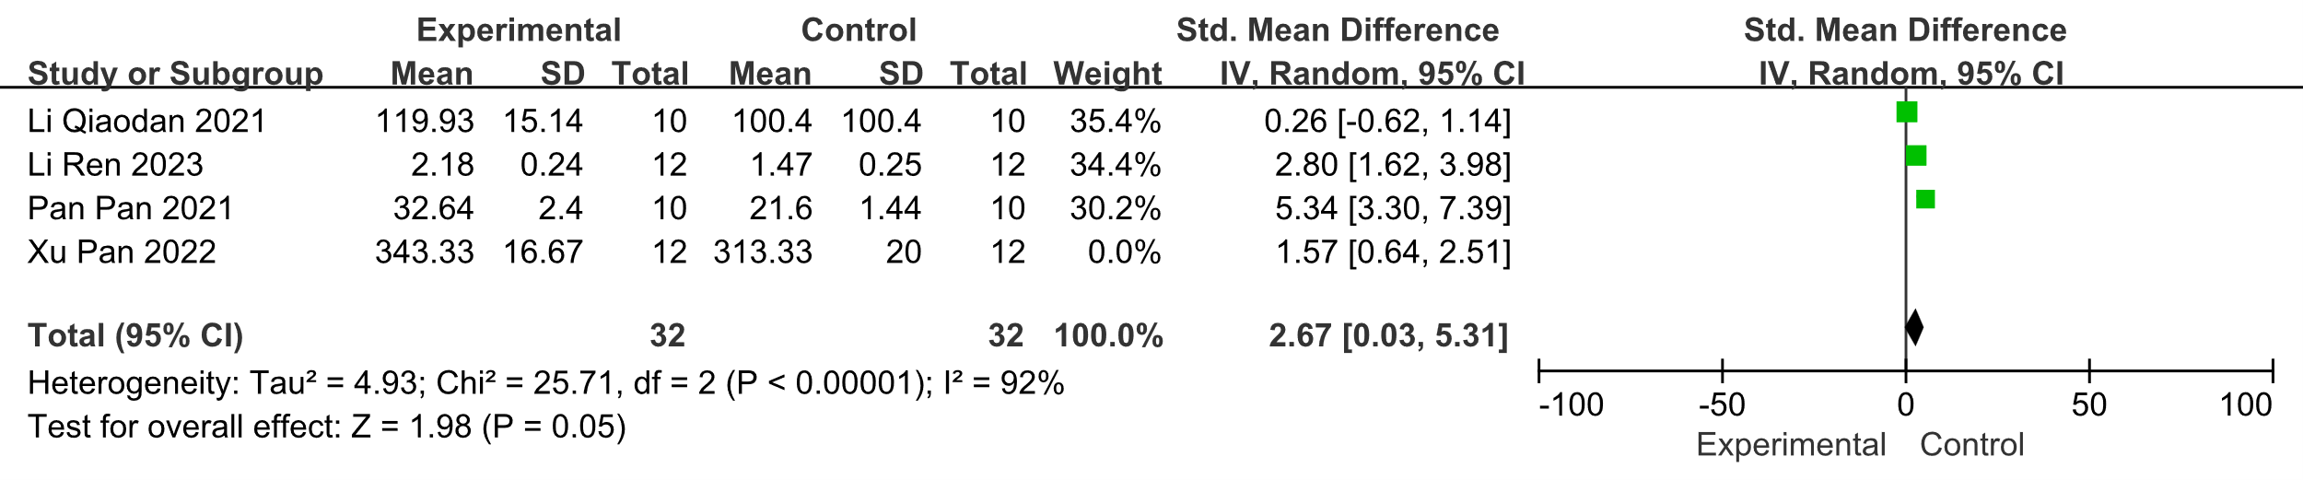

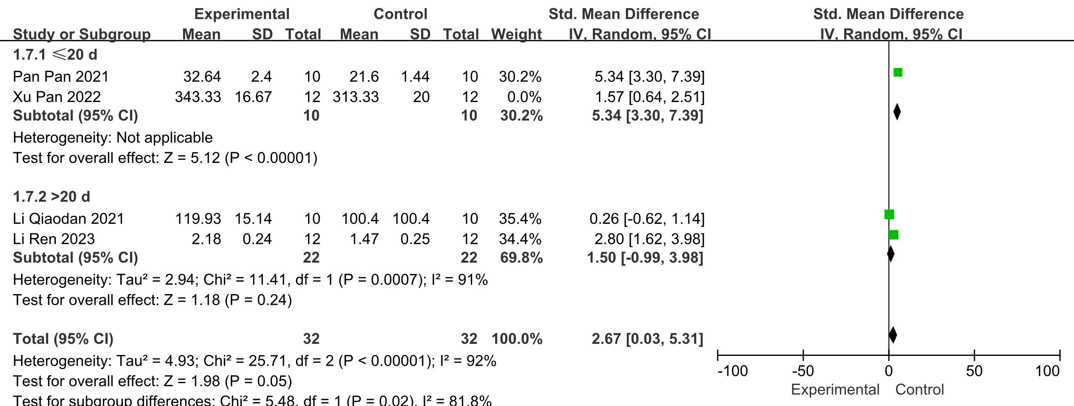

9 Forest plot of IL-10 for sensitivity test

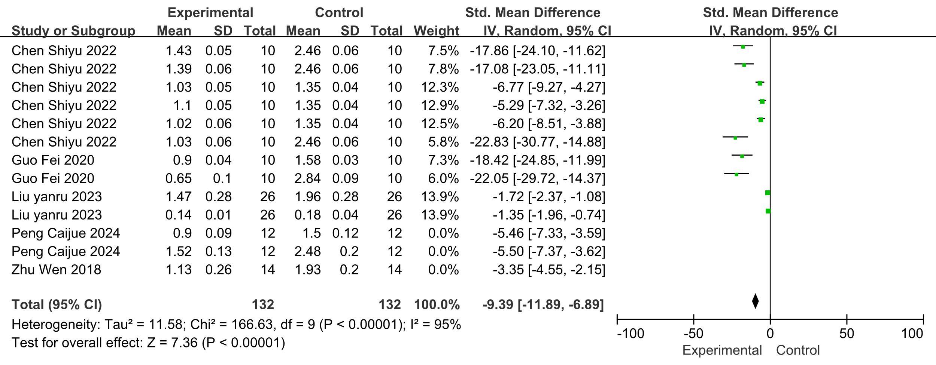

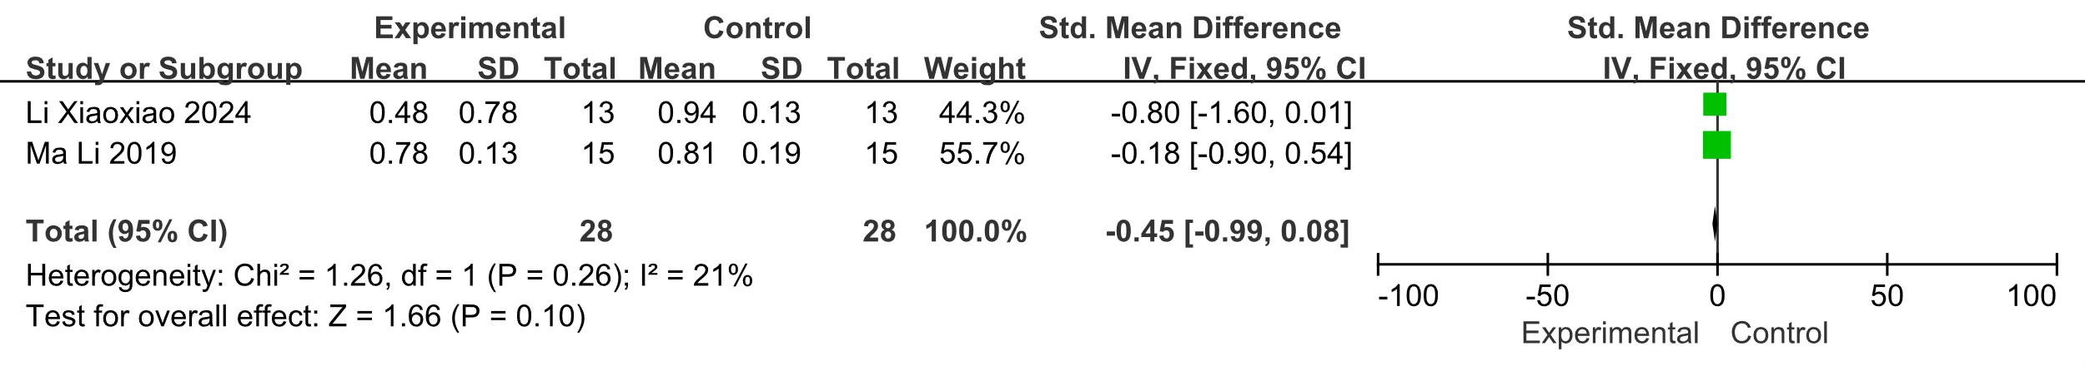

10 Forest plot of JNK for sensitivity test

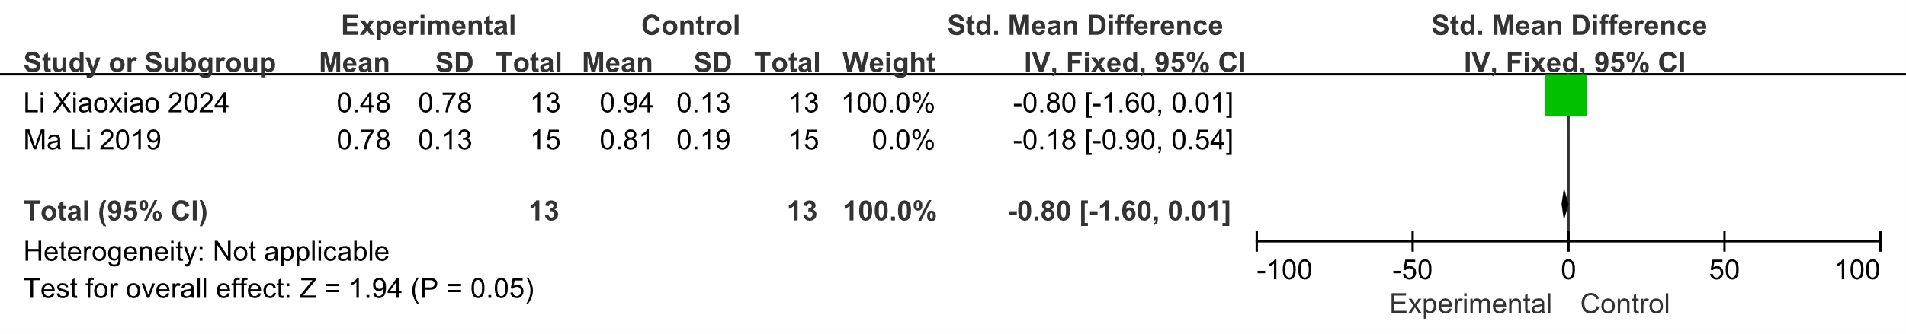

11 Forest plot of MAPK p38 for sensitivity test

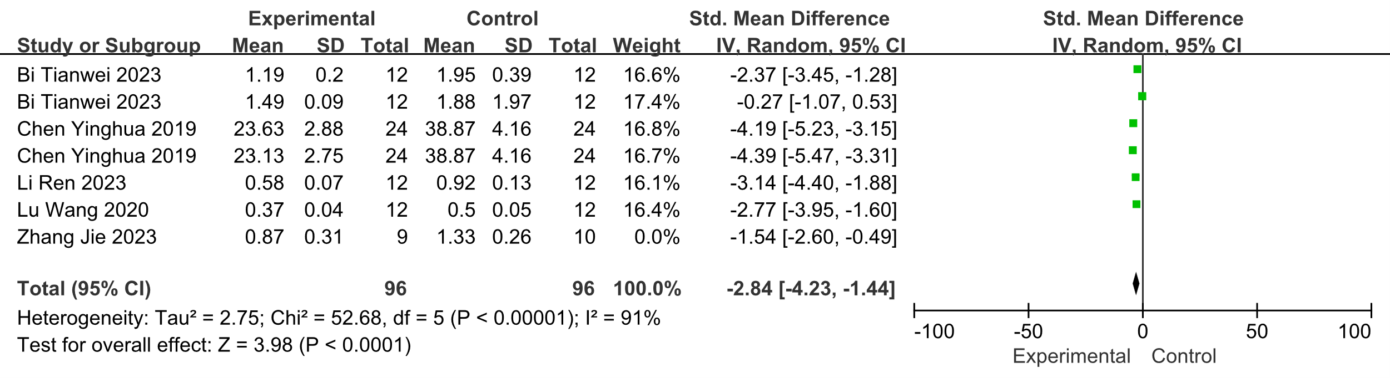

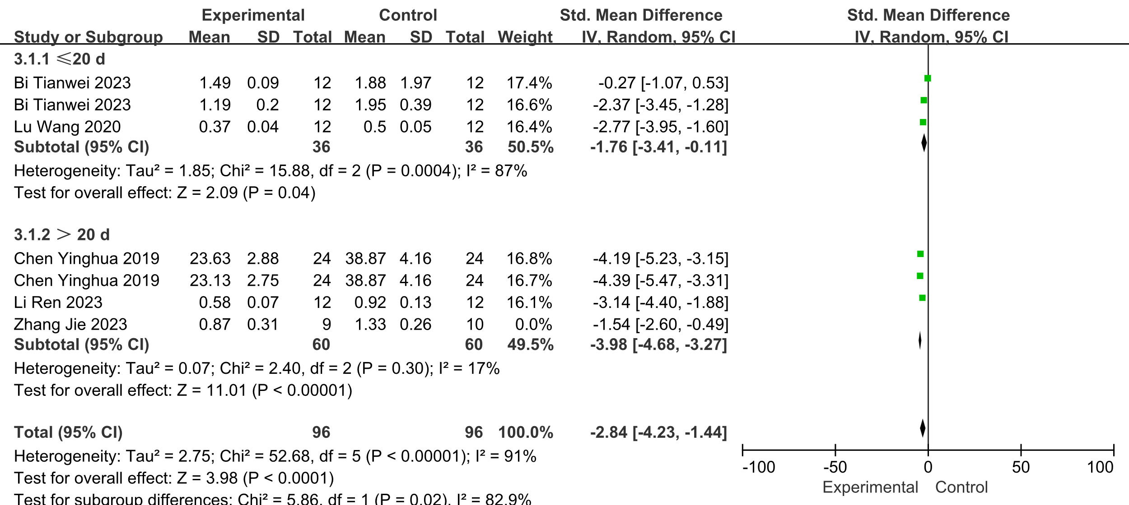

12 Forest plot of NF-κB for sensitivity test

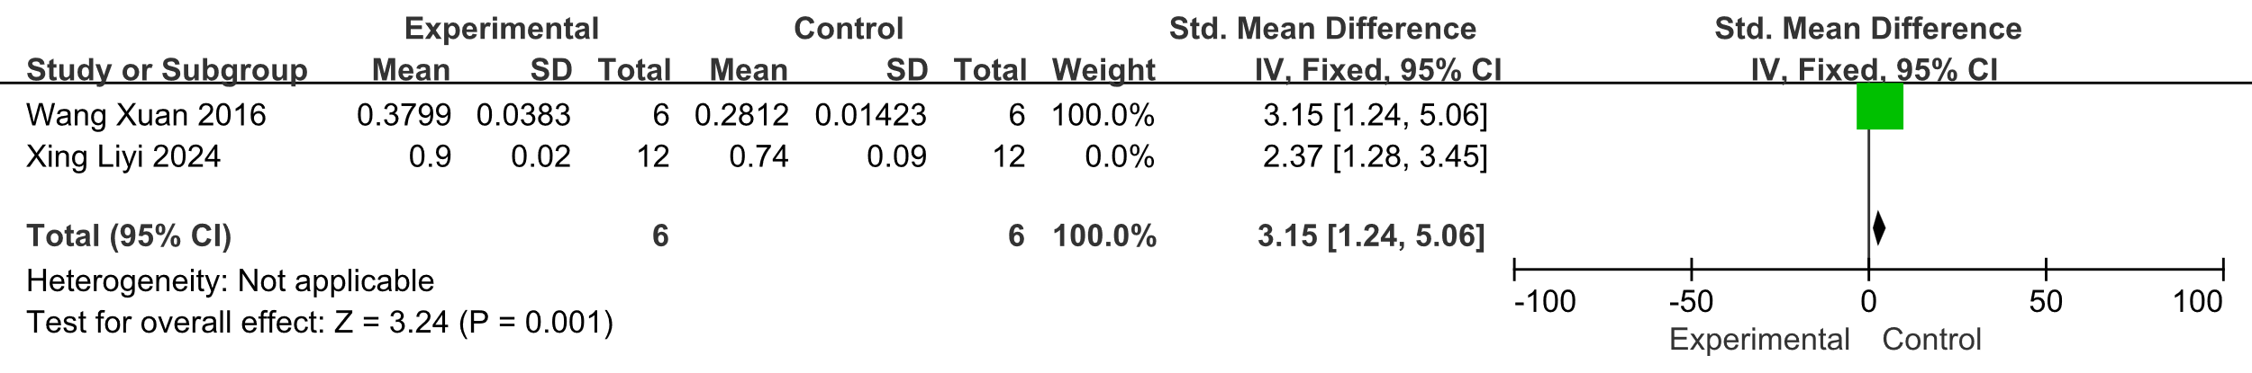

13 Forest plot of PI3K for sensitivity test

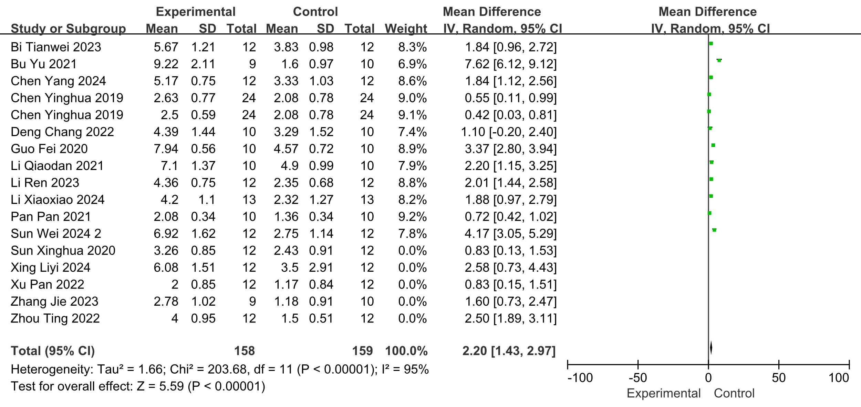

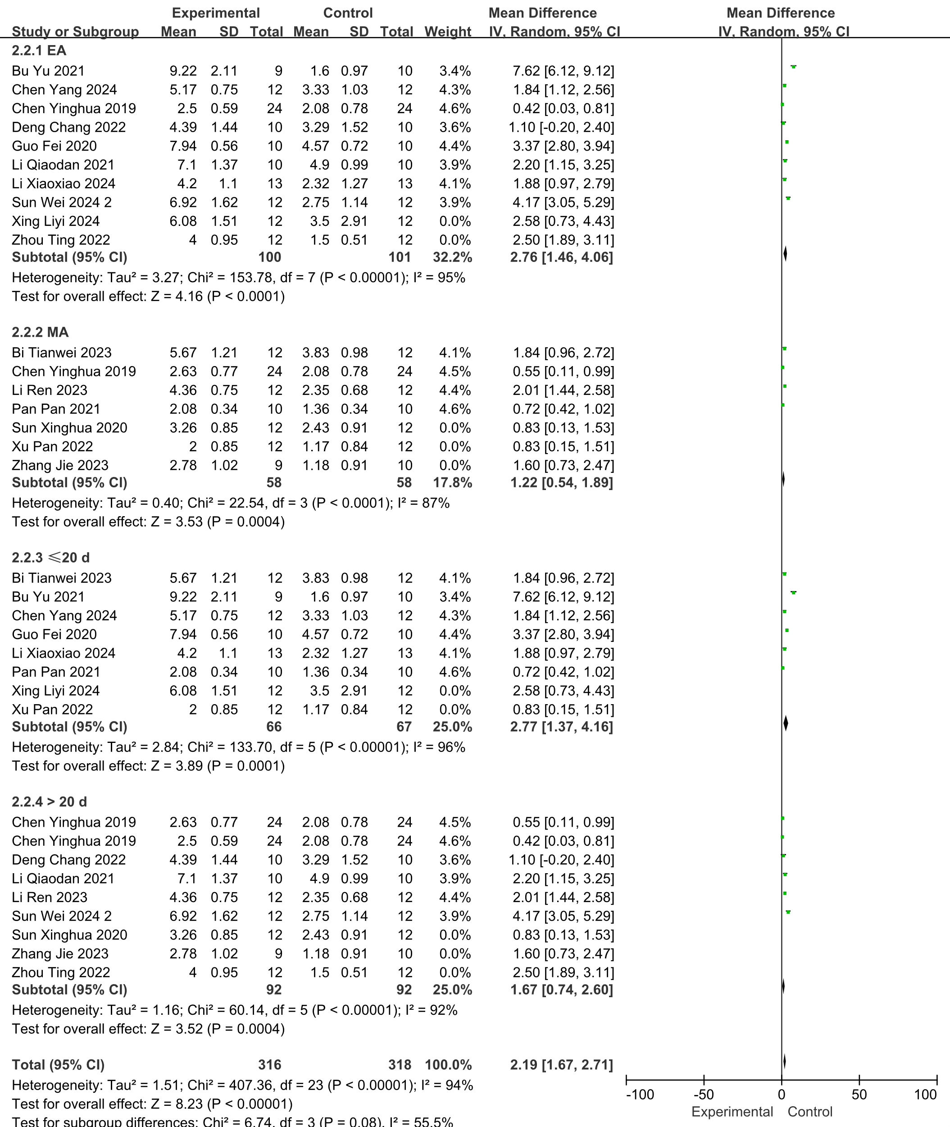

14 Forest plot of platform crossing times for sensitivity test

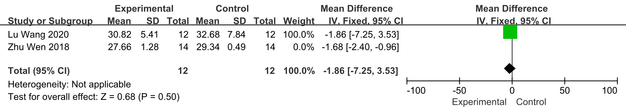

15 Forest plot of swimming speed for sensitivity test

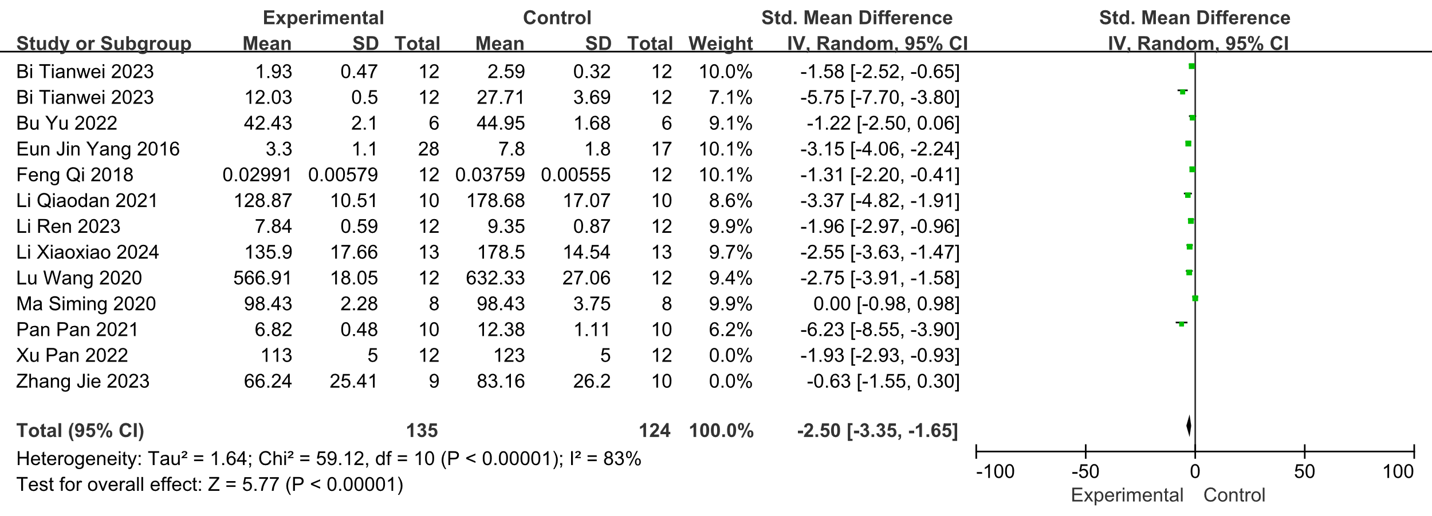

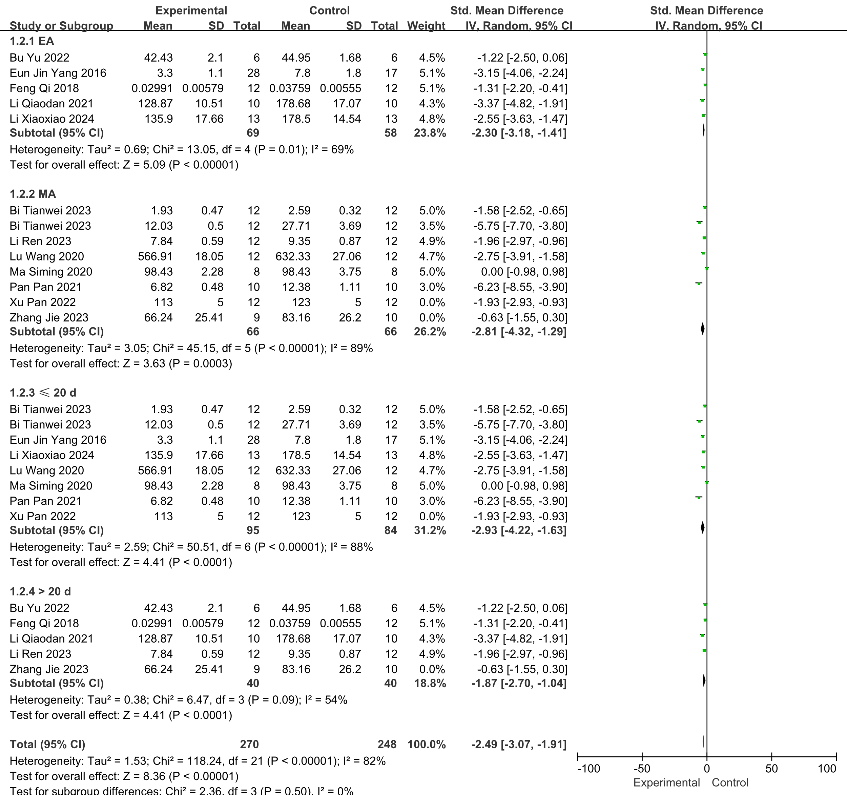

16 Forest plot of TNF-α for sensitivity test